Site Review 4
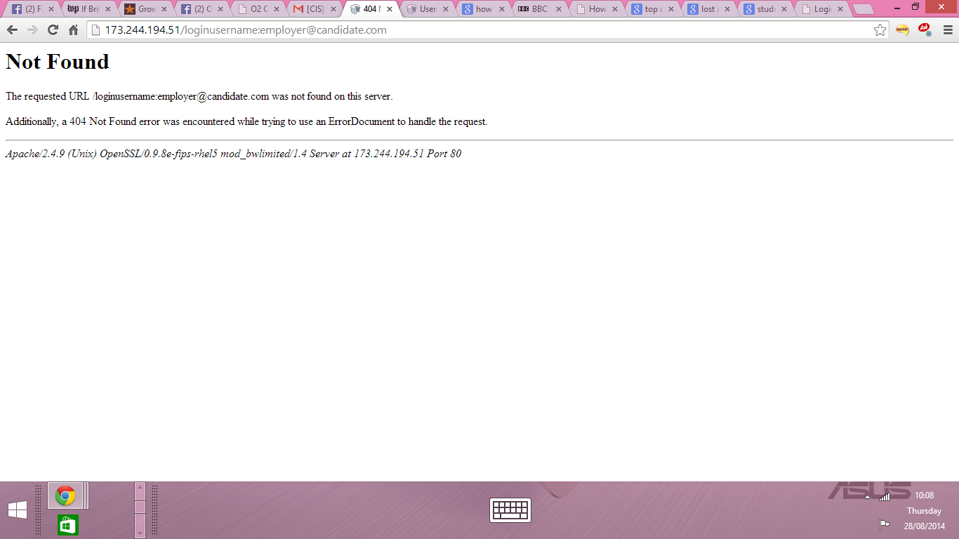
Unfortunately with the links you provided for the video chat are all producing this error
Under Groups - Please center the Group’s Mission /Purpose like this- The Group’s
Mission/ Purpose - if not possible to center like above, please just have The Group’s Purpose on one line.

- 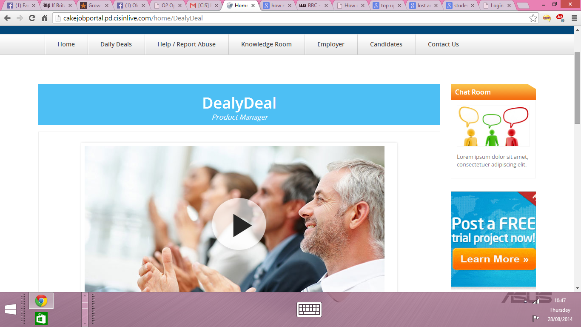
- Please ensure that the banners have the correct spellings and please remove project manager from the title. Following banners need amending
Such as
- Daily deal
- About us
- Why us
- Training
- Our partners
- Get involved
- upcoming events
- Other ways to help
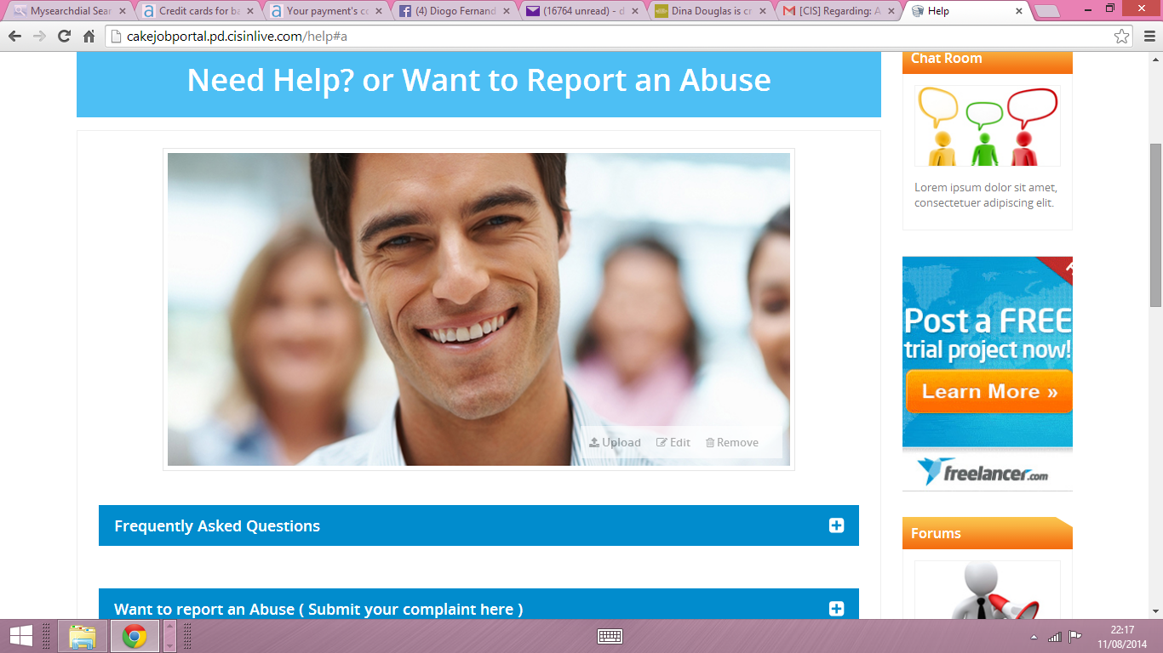
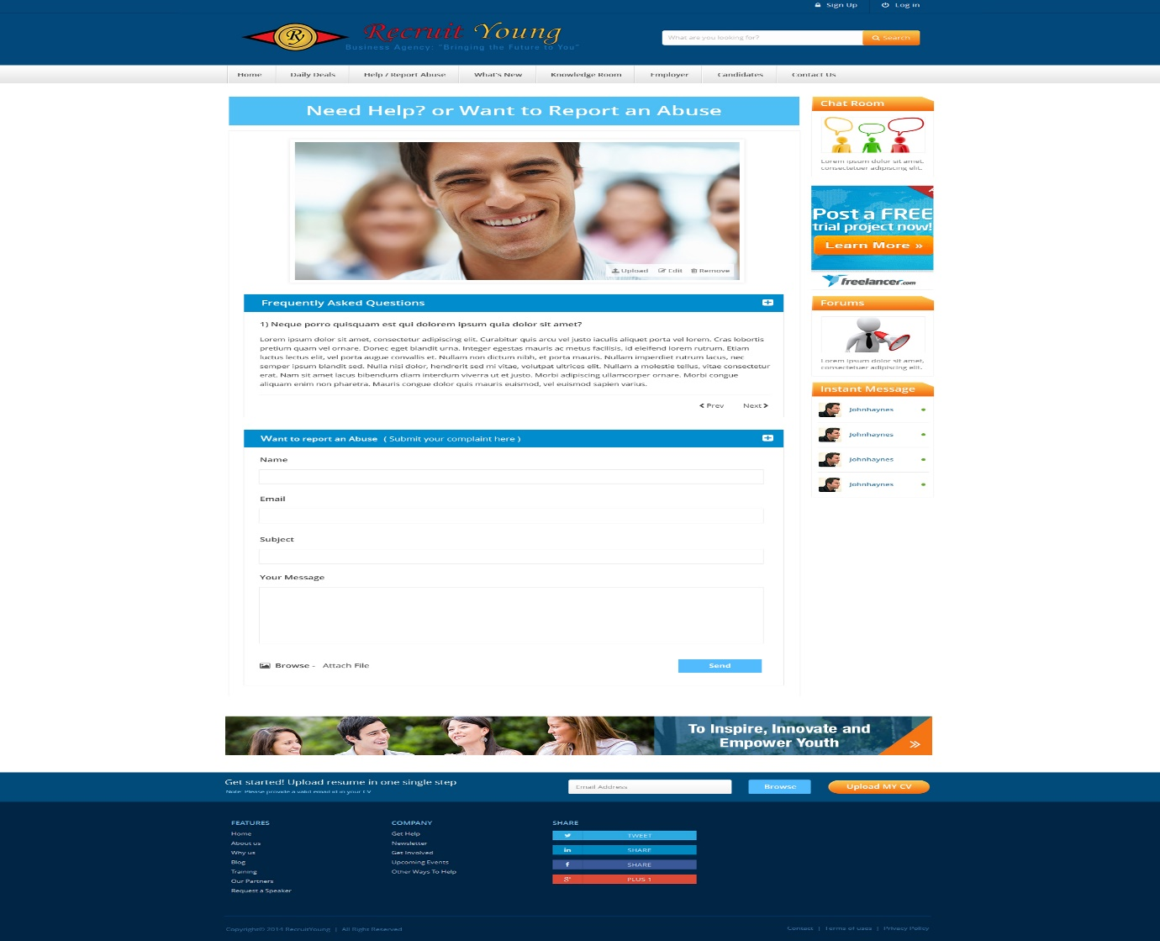
Please ensure that the layout looks like the second image rather that the first. I believe the second layout is better and more user friendly.

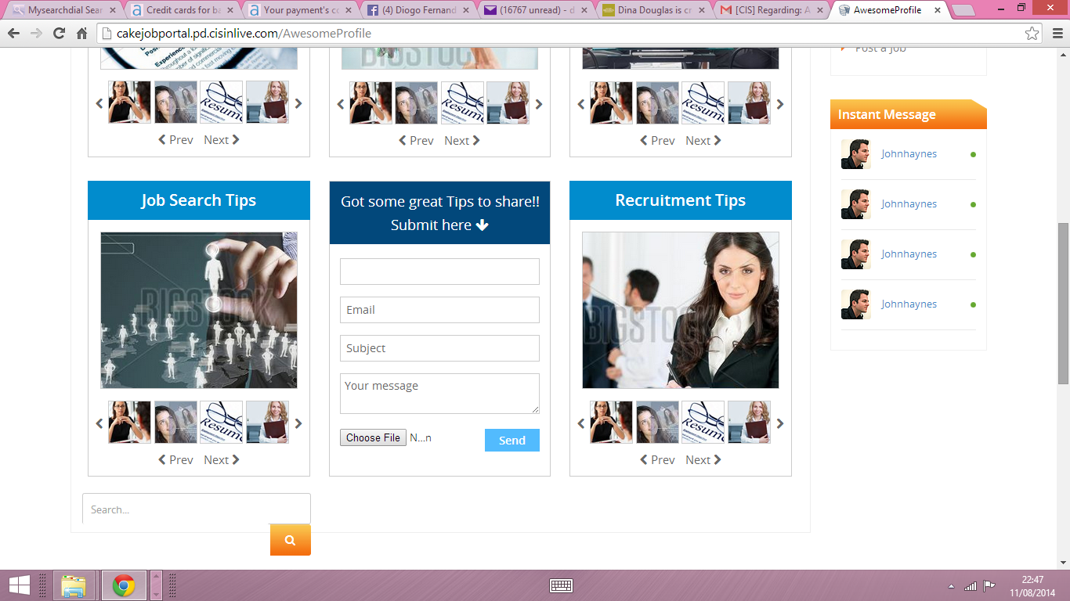
Please correct the search design button here because it is out of line. Also next the choose file please remove the N…n writing 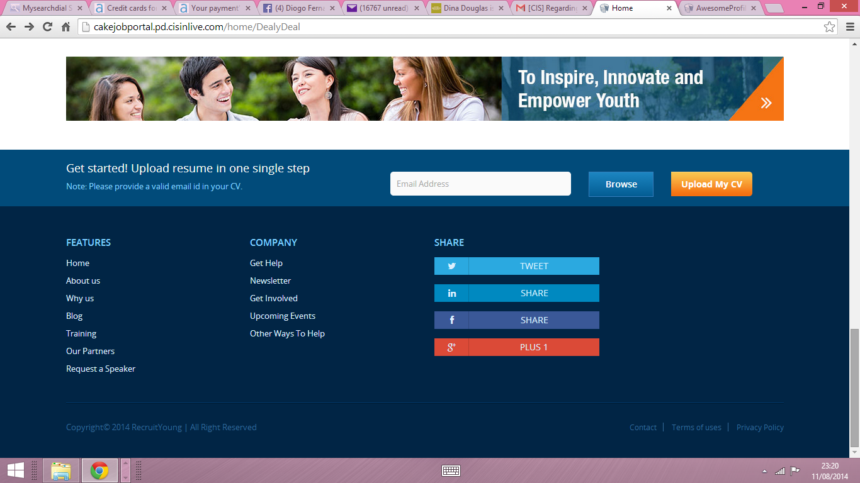
The share button should be “ Connect” instead since it does not allow the user to share this site to the listed social media sites but connect with the company’s social media pages. Otherwise this share feature should allow the user to share this site on the social media site listed here.

